Pedagogical Agents in the Educational Multimedia for Children.
Virtual Travel Around the Course of Natural Sciences

M. Morozov, A. Tanakov and D. Bystrov
Multimedia System Laboratory
Mari State Technical University
pl. Lenina, 3 , Yoshkar-Ola, 424000, Russia
morozov@marstu.mari.ru

This paper presents a multi-agent educational multimedia system for the school course in Natural Sciences. Three animated characters (Teacher, Schoolboy and Schoolgirl) take a virtual tour in order to learn basic Physical and Chemical phenomena and concepts. The paper also describes the authoring environment NATURA and scripting language NML that were developed for creating this multimedia system.

I. INTRODUCTION

The rapidly growing amount of instructional multimedia software is accompanied by increasing research in new forms of multimedia presentation and interactivity.
One of the modern and progressive techniques in Human-Computer Interface design is the application of interface agents – on-screen animated characters. Interface agents enable computer interfaces to become more human or more “social” [1]. In educational software, the interface agent does not act only as a guide, navigating the learner through a virtual world, but also perform the most important tasks of a teacher (delivering knowledge to the learners, monitoring progress, providing feedback) [2]. It was also found that life-like animated agents have an exceptionally positive impact on children and can increase their motivation and attention [3].
In this paper we describe the creation of multi-agents educational multimedia software for school course of Natural Sciences. Three life-like animated characters (Teacher, Schoolboy and Schoolgirl) take a virtual travel in order to learn basic Physical and Chemical phenomena and concepts. The authoring environment NATURA and scripting language NML developed for creating this educational multimedia software are presented.

II. PEDAGOGICAL AGENTS IN THE VIRTUAL WORLD OF NATURAL SCIENCES

The appearance of life-like animated characters as the interface agents was a logical step in the evolution of a graphic user interface. It is caused by the fact that the use of the agent technology in a human-computer interface allows the user to join a ‘face to face’ virtual dialogue where the interface agent provides a mutual information exchange [4].
Interface agents for educational software are called the pedagogical agents. These agents usually have enough understanding of the educational context in order to be able to play useful roles in learning scenarios for students [5].
Pedagogical agents are also used to create effective educational software for children. Beside the aforementioned advantages of using the agents for providing learning materials to the pupils, the application of animated human-like characters allows the creation of an educational environment similar in appearance to computer games. It helps to stimulate children’s interest in utilizing such a program and therefore it can add motivational value to learning.
All these potential benefits associated with pedagogical agents were reasons to include the animated characters in the concept of the multimedia software for teaching Natural Sciences to 10-12 year old children. The new form of multimedia presentation allows us to create an effective educational environment for learners to be able to grasp and retain some of the fundamental concepts of Physics and Chemistry.
When choosing the right character for the role of the pedagogical agent, many factors must be taken into account, including the pedagogical functions of this agent, a target audience and the educational content of the courseware [6].
Presentation and explanations are considered to be the major functions of the pedagogical agent in this project. It is obvious that the agent acting alone as a Teacher would perfectly perform those functions. A traditional monologue lecture format however is not appropriate for pupils of primary school age who are mentally, socially and emotionally ready for much more vivid and lively forms of teaching. The transition to a multi-agent learning environment with agents interacting will be more suitable in this case.
For centuries, the teaching method most widely used has been known as the ‘Socratic dialogue’. This term refers to conversations between the Teacher and Learners in order to discover the truth. The form of such dialogues has also been applied to explain complex concepts and theories in a clear fashion. For example, such notable writers as Giordano Bruno, Galileo Galilei, and Voltaire, cast their works in the dialogue form. At present, in the modern e-learning systems, the ‘Socratic’ method of teaching is employed to help the students better understand and learn from the course content. It is also important to note that the dialogues and discussions, not only between teacher and learner but also among learners are an essential part of a traditional classroom activity.
For these reasons an agent ‘learner’ makes an appearance alongside the agent ‘teacher’ in the virtual world of educational software. The agent ‘learner’ can put questions to the teacher, listen to his answers, and then answer questions from the agent ‘teacher’. However, the communications between a teacher and one pupil only cannot reproduce the whole social-psychological context of a real educational environment. For this purpose the communication formula ’a teacher and two pupils (a boy and a girl)’ is more appropriate.

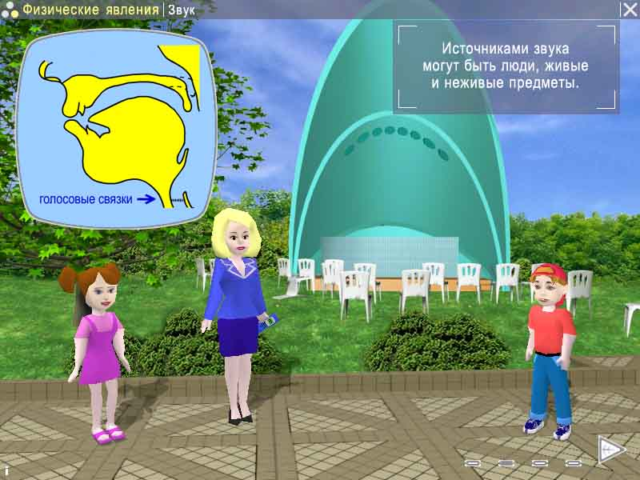
Fig. 1. Pedagogical agents in multimedia Natural Sciences

Therefore, three autonomous pedagogical agents named Tatyana Mikhailovna (a teacher), Masha (a girl, a brilliant pupil) and Petya (a boy, an inquisitive and creative child) (Fig. 1) act in this virtual educational environment.
The inclusion of such a ‘group’ of pedagogical agents allowed us to resolve the following problems:
- to create a micro-model of lesson activity – a child's customary environment;
- to improve the opportunities for dramatizing agent dialogues;
- to give a reliable support to individual learner differences.
Besides, the functions of interaction with the virtual world objects are assigned on the pedagogical agents for the purposes of the investigation and demonstration of physical processes.

III. NATURA: AUTHORING ENVIRONMENT FOR EDUCATIONAL MULTIMEDIA SOFTWARE

A powerful software tool is required for the development of the multi-agent environment with a lot of different media objects. Modern computer game engines possess such capabilities for presentation. However there are financial restrictions on the employment of those engines for the development of educational software. It should be noted that VRML, often used for educational purposes, does not have enough expressive power for multimedia learning environments with pedagogical agents. Therefore a new authoring environment, both technology-effective and functionally-rich, has been designed to create the multimedia software for Natural Sciences teaching.

A. NML scripting language

Using internal scripting language is the best to create computer games and educational multimedia software, which combines 2D-graphics and real-time 3D animation. The main advantage of scripts is that they can to describe exactly all multimedia presentation details (visual appearance and spatial location of the graphical elements, temporal synchronization of media-components, interactivity).
Fig. 2. The multimedia objects hierarchy in NML

Further, scripting languages makes easier process of development multimedia products with media-rich presentation and high-level interactivity.
Taking that into account, NATURA authoring environment has been designed to create the multimedia product for Natural Sciences teaching. The NATURA consists of a rendering engine and tools for preparing multimedia data and the script of their presentation.
In the authoring environment, the script is written in a special developed NML language (Natura Multimedia Language) and is translated into a binary code for more effective application in presentations.
In NATURA authoring environment, the presentation model employs a hierarchical structure consisting of scenes, multimedia objects and their compositions. (Fig. 2)
The description of multimedia presentation in the NML language is performed in the following order. The constants are defined in the beginning of the script, then follow the templates of multimedia objects, compositions and scenes. Next, the scenes themselves are described. Each scene gets its name and the description of the multimedia objects, compositions and events. The list of basic multimedia objects used in NML is given in Table 1.

TABLE I
MULTIMEDIA OBJECTS IN NML

Image | Static graphics
Anim | Animation
Audio | Sound
Video | Video clip
Html | HTML-document
Object3d | Mesh based 3D object
Motion | 3D object motion
Speech | Speech of 3D character
Camera | Camera in 3D-world
Light | Lighting

B. NATURA Engine

The NATURA engine renders multimedia objects. NATURA engine includes several modules (managers): Application Manager, Scene Manager, Render Manager, Sound Manager and Resource Manager. The structure diagram of the NATURA engine is given in Fig. 3.
The NATURA engine works as follows. The Application Manager initializes graphical libraries, creates the main window, initializes other managers, and passes the control to the Scene Manager. The Scene Manager
Fig. 3. The structure diagram of the NATURA engine

loads the script of a starting scene, runs threads for loading multimedia elements and initializes them. Next, the control is transferred to the Render Manager, which requests the list of visible elements from the Scene Manager. The Render Manager filters visible elements and displays the result on the screen. While a presentation is played visible dynamic media can send the messages about the necessity of updating its image to the Render Manager. The Render manager, in its turn, requests from the Scene Manager the list of all visible elements intersected with this element and displays their union on the screen.
When the “go” command is executed, the Scene Manager pauses the Render Manager and Sound Manager, and then removes from memory an old scene and all its multimedia objects. Next, a new scene and all its multimedia objects are loaded and initialized. The Render Manager and Scene Manager then resume their execution.

IV. INTERACTIVE MULTIMEDIA NATURAL SCIENCES SOFTWARE FOR CHILDREN

The rich possibility of the developed authoring environment allowed us to create intriguing learning software. Pedagogical agents, a teacher Tatyana Mikhailovna and her pupils Masha and Petya, are taking a walk through the virtual islands "Matter", "Forces" and "Physical phenomena". They can go to the forest, to the park, to the stadium, to the beach and to many other places, where they can learn many new and interesting things about basic physical and chemical concepts and phenomena.
Various forms are used for the presentation of learning materials in this multimedia software. The agent-pupils do not just listen to the teacher and ask her questions. They also interact with the objects in a scene for the demonstration of physical science phenomena. For example, in the lesson on the concepts of friction, Petya goes down the children’s slide, roller-skates in the park and attempts to shift a car manually. When Newton’s laws are studied, Petya and Masha ride bumper cars. Furthermore, a set of learning exercises with game-like interactivity is also incorporated into this learning environment. Thus children perform both interactive and pedagogical exercises with agents assisting them during this process.

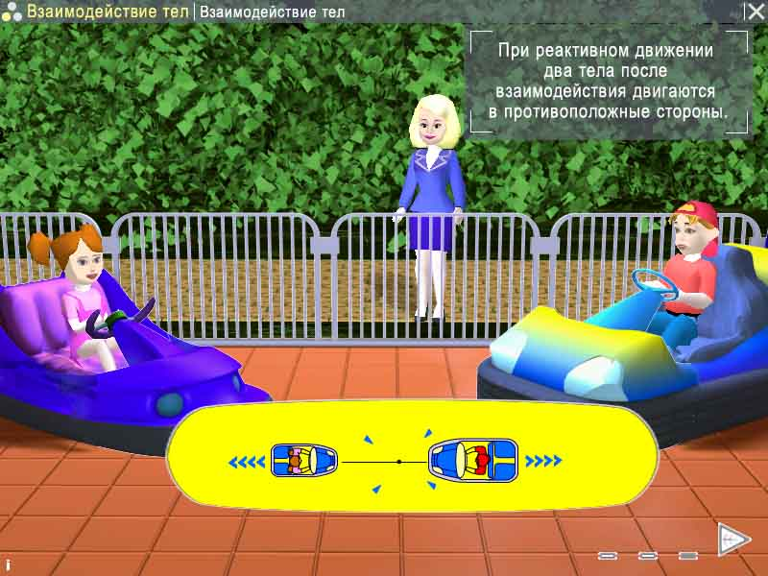
Fig. 4. Petya and Masha are studying Newton’s laws

V. CONCLUSION

For years advanced forms of multimedia (real-time 3D characters, virtual reality) have been used in the computer game industry with excellent results. Now they are starting to be adopted in the Computer Based Learning industry. However, many efforts will be needed to realize new potentialities and possibilities for creating educational multimedia software, which is not only exciting, but also effective. The interactive multimedia Natural Sciences software for children and authoring engine NATURA presented in this paper are one of the steps on the way to a new generation of multimedia learning systems.

REFERENCES

[1] B. Hermans, “Intelligent Software Agents on the Internet”, FirstMonday, vol. 2, 3/1997.
[2] A. Nijholt, “Agents, Believability and Embodiment in Advanced Learning Environments”, Proc. IEEE International Conference on Advanced Learning Technologies (ICALT 2001), T. Okamto, R. Hartley, Kinshuk & J.P.Klus (eds.), 2001, pp. 457-459.
[3] J.C. Lester, S.A. Converse, S.E. Kahler, S.T. Barlow, B.A. Stone, and R.S. Bhogal, “The persona effect: Affective impact of animated pedagogical agents”, Proceedings of CHI ’97, 1997, pp. 359-366, ACM Press.
[4] Hsuan-Yuan Huang, “The persuasion, memory and social presence effects of believable agents in human-agent communication”, Proceedings of Third International Cognitive Technology Conference, CT'99 (San Francisco/Silicon Valley, 1999).
[5] E. Shaw, W.L. Johnson, R. Ganeshan, “Pedagogical Agents on the Web”, Agents 1999: 283-290.
[6] R. Moreno, “Life-like pedagogical agents in constructivist multi-media environments”, EDMEDIA 2000, pp.741-746.

